**Extended Events**

**Answer 1:**

CREATE EVENT SESSION [long_batch] ON SERVER

ADD EVENT sqlserver.sql_batch_completed(

WHERE ([duration]>(5000000)))

GO

**Answer 2:**

CREATE EVENT SESSION [depracted_Feature] ON SERVER

ADD EVENT sqlserver.deprecation_announcement(

ACTION(sqlserver.client_hostname,sqlserver.database_name,sqlserver.sql_text)

WHERE ([sqlserver].[database_id]>(4))),

ADD EVENT sqlserver.deprecation_final_support(

ACTION(sqlserver.client_hostname,sqlserver.database_name,sqlserver.sql_text)

WHERE ([sqlserver].[database_id]>(4)))

GO

select @@VERSION



SELECT * FROM sys.dm_os_performance_counters

WHERE object_name = 'SQLServer:Deprecated Features';

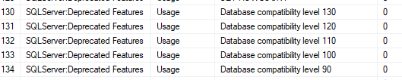

alter database northwind

set compatibility_level = 110

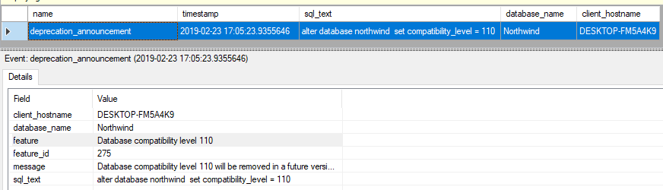

**Answer 3:**

CREATE EVENT SESSION [deadlock_monitor] ON SERVER

ADD EVENT sqlserver.lock_deadlock(

ACTION(sqlserver.client_hostname,sqlserver.database_name,sqlserver.sql_text)),

ADD EVENT sqlserver.lock_deadlock_chain(

ACTION(sqlserver.client_hostname,sqlserver.database_name,sqlserver.sql_text))

WITH (MAX_MEMORY=4096 KB,EVENT_RETENTION_MODE=ALLOW_SINGLE_EVENT_LOSS,MAX_DISPATCH_LATENCY=30 SECONDS,MAX_EVENT_SIZE=0 KB,MEMORY_PARTITION_MODE=NONE,TRACK_CAUSALITY=OFF,STARTUP_STATE=OFF)

GO

**Answer 4:**

CREATE EVENT SESSION [function_history] ON SERVER

ADD EVENT sqlserver.sequence_function_used(

ACTION(sqlserver.client_hostname,sqlserver.database_name,sqlserver.sql_text)),

ADD EVENT sqlserver.window_function_used(

ACTION(sqlserver.client_hostname,sqlserver.database_name,sqlserver.sql_text))

GO

**Answer 5:**

CREATE EVENT SESSION [page_split ] ON SERVER

ADD EVENT sqlserver.page_split(

ACTION(sqlserver.database_name,sqlserver.query_hash,sqlserver.sql_text))

GO

